Steps for Running an Angular application using Nodejs & VisualCode Editor

Angular App Working Code:
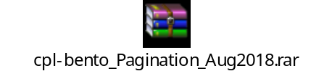

Install nodejs
Install VisualCode Editor

Open VisualCode Editor
Goto File --> Open Folder and select the angular application root folder
Goto View --> Open Integrated Terminal

Test if npm is working properly
npm -v
node -v

npm install --> This will import all the related packages just like Maven
npm start --> this will call "ng serve", written in package.json
Now open browser and enter url --> http://localhost:4200/ --> You will see the working app

npm run build --> this will call "ng build" written in package.json. This step is needed for deployment of angular app.

Folder "dist" will be created in the angular app which contains .js files mentioned below:
index.html
inline.bundle.js
main.bundle.js
polyfills.bundle.js
styles.bundle.js
vendor.bundle.js

We can copy these files to s3 bucket in AWS and host our static website by pointing our index.html file as startup file.

Addition:

Springboot REST service used by above Angular App with Pagination:
